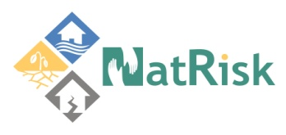
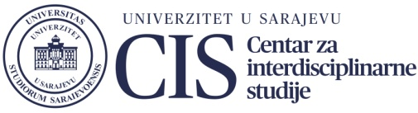

Obavijest

U četvrtak, 22.11.2018. godine, u 17:00 sati, uvaženi prof.dr Roland Kaitna sa Univerziteta BOKU (Institute of Mountain Risk Engineering, Department of Civil Engineering and Natural Hazards, University of Natural Resources and Life Sciences) iz Beča održat će predavanje na temu:
Meteorological and hydrological trigger conditions of torrential processes and Impact of climate change on mountain hazards

